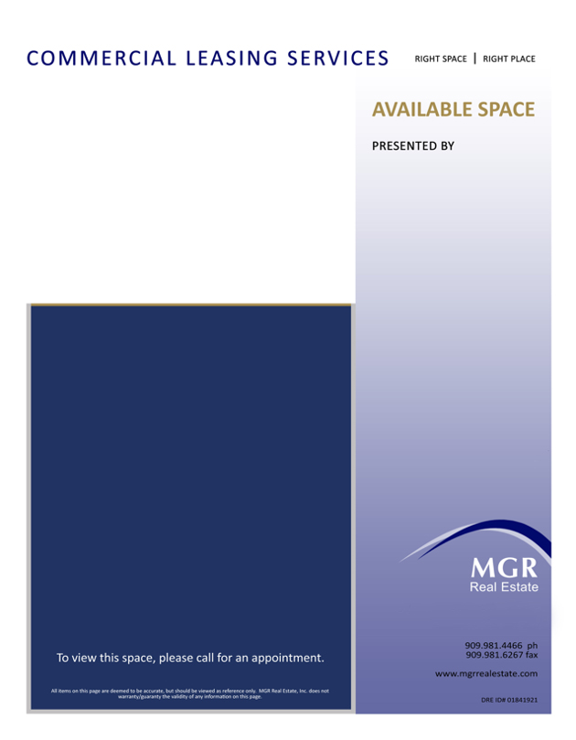

3800 E. Concours St., Suite 100, Ontario, CA 91764

**Enter City Location Here, CA**

Enter short description of property and location here. Enter short description of property and location here. Enter short description of property and location here. Enter short description of property and location here. Enter short description of property and location here. Enter short description of property and location here. Enter short description of property and location here.

Features

* Enter description / feature / amenity here
* Enter description / feature / amenity here
* Enter description / feature / amenity here
* Enter description / feature / amenity here
* Enter description / feature / amenity here
* Enter description / feature / amenity here
* Enter description / feature / amenity here

More…

* Enter description / feature / amenity here
* Enter description / feature / amenity here
* Enter description / feature / amenity here
* Enter description / feature / amenity here

**Name(1) Here**

Associate Title

909.000.0000

youremail@mgrrealestate.com

DRE Lic #00000000

**Name(2) Here**

Associate Title

909.000.0000

youremail@mgrrealestate.com

DRE Lic #00000000