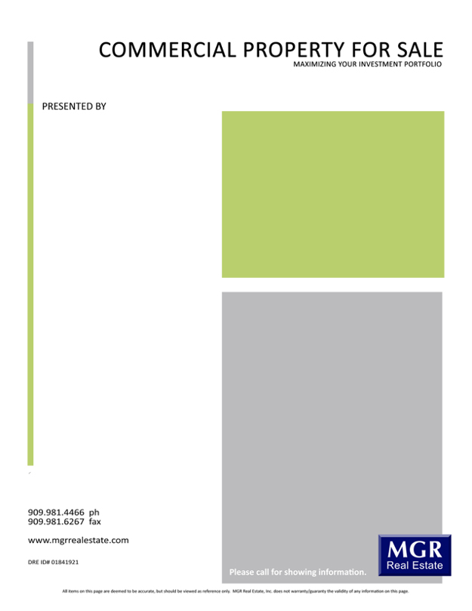

3800 E Concours St Suite 100, Ontario, CA 91764

$Price

Enter a marketing piece about this property here. Enter a marketing piece about this property here. Enter a marketing piece about this property here. Enter a marketing piece about this property here. Enter a marketing piece about this property here. Enter a marketing piece about this property here.

**Enter City Location Here, CA**

Enter a summary description here. Enter a summary description here. Enter a summary description here. Enter a summary description here. Enter a summary description here.

Features

* Enter description / feature / amenity here
* Enter description / feature / amenity here
* Enter description / feature / amenity here
* Enter description / feature / amenity here
* Enter description / feature / amenity here
* Enter description / feature / amenity here
* Enter description / feature / amenity here

Available Suites

* List available space here
* List available space here
* List available space here

**Name(1) Here**

Associate Title

909.000.0000

youremail@mgrrealestate.com

DRE Lic #00000000

**Name(2) Here**

Associate Title

909.000.0000

youremail@mgrrealestate.com

DRE Lic #00000000