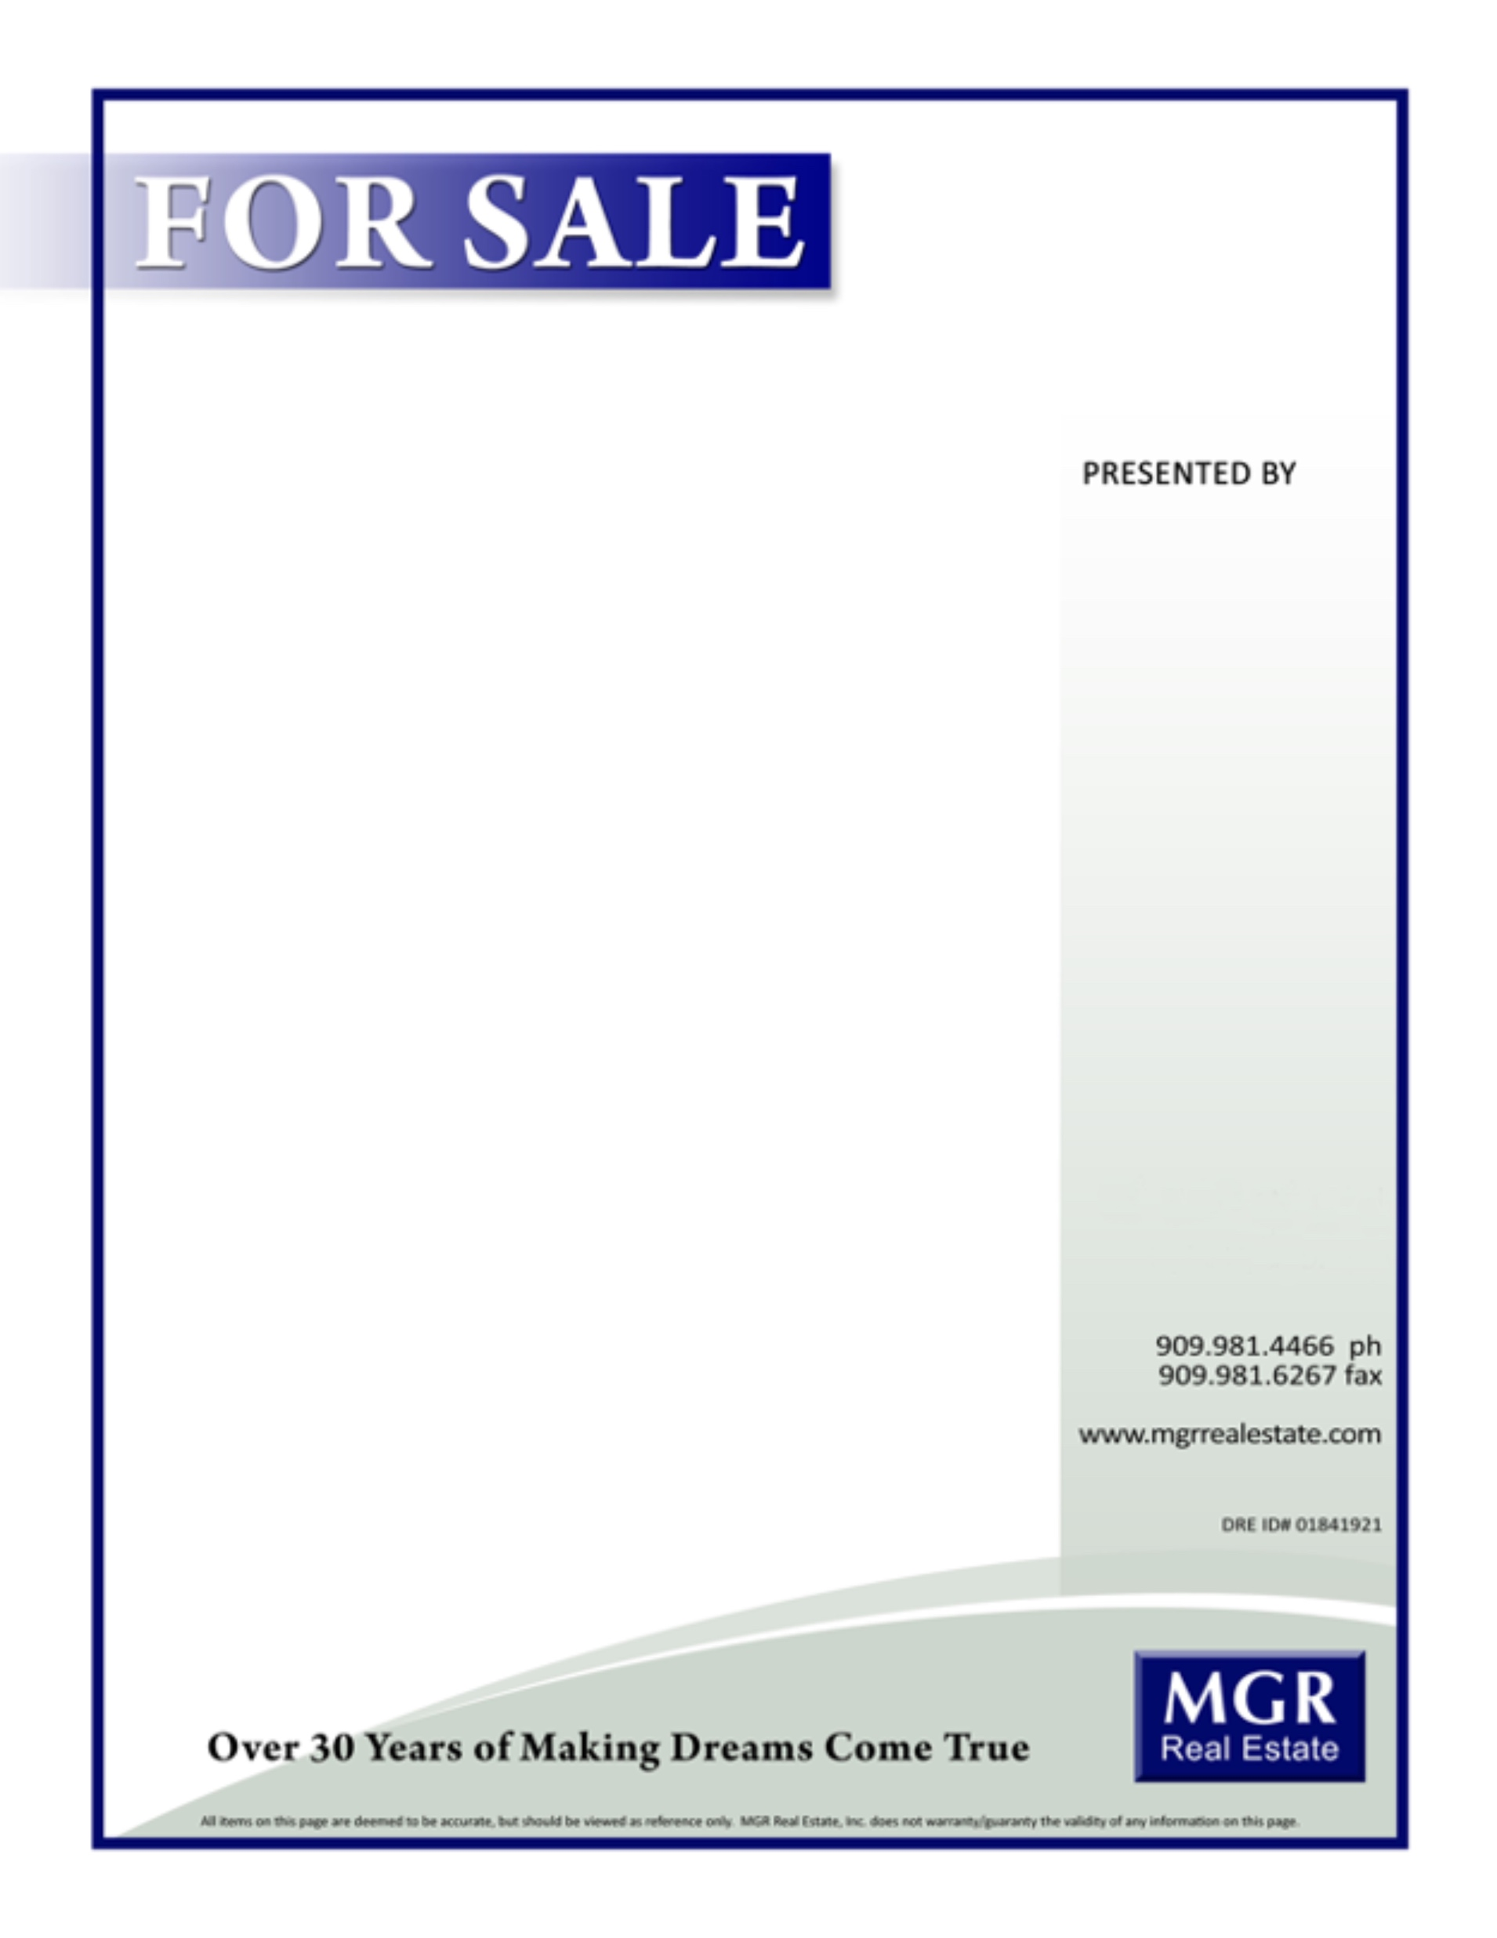

3800 E Concours St Suite 100, Ontario, CA 91764

**Your Name**

**900.900.9000**

youremail@mgrrealestate.com

DRE Lic# 00000000

**Stop by and tour this extraordinary home. It won’t last long!**

**FALALAVILLE, CA**

* Add your description / feature here
* Add your description / feature here
* Add your description / feature here
* Add your description / feature here
* Add your description / feature here

More…

* Add your description / feature here
* Add your description / feature here
* Add your description / feature here
* Add your description / feature here
* Add your description / feature here
* Add your description / feature here

**$Price**